GUV-CFD Simulation Report

Illuminate room design file: …guv
CFD Project file: ….guvcfd
OpenFoam directory: \\wsl.localhost\Ubuntu\home\hclaus\OpenFOAM\hclaus-v2412\run\patient_ward_4B1_v3
Simulation date | 2026-07-14 09:58
Total elapsed time | 51m 29s
CPU | 12th Gen Intel(R) Core(TM) i7-1255U
RAM | 15.7 GB
GPU | Intel(R) Iris(R) Xe Graphics (not used - this pipeline's OpenFOAM solve is CPU-only)

Room Setup
Room dimensions | 3.2 x 4.8 x 2.57 meters
Lamps | 4
Ventilation ACH | 6 /hr
UV inactivation constant Z | 6 cm²/mJ
Inlet 1 | xMax, y=2.4m z=2.4m, size=0.6x0.3m
Outlet 1 | xMax, y=2.4m z=1.3m, size=0.6x0.3m
Inlet 2
Outlet 2
Injection point
Monitoring point (name)

Case Setup
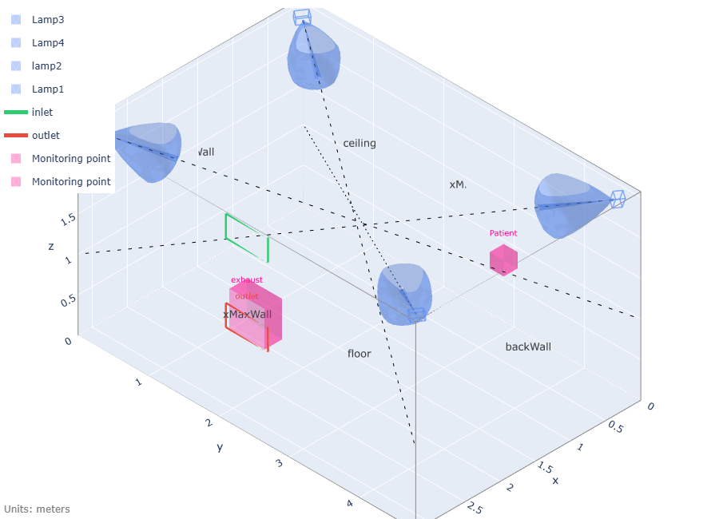

Results
Note: T is the OpenFOAM field name for the transported scalar this whole simulation tracks - the substance being reduced, per unit volume. In a GUV disinfection context this is typically a pathogen concentration, e.g. CFU/m³ (colony-forming units per cubic meter) or an equivalent airborne-contaminant unit; the CFD itself is unit-agnostic and just tracks relative concentration.
Average fluence rate | 2.869 µW/cm²
Target well-mixed steady-state T | 0.3
Source injection rate (calculated to achieve target T) | 0.01974 T-units/s (see T note below)
Phase 1 T_ss (no UV) room average | 0.2452 (NOT fully plateaued, 8000 iterations)
Phase 2 T_ss (UV on) room average | 0.03132 (NOT fully plateaued, 5000 iterations)
Reduction | 87.2%
Theoretical eACH_uv, steady-state (well mixed ventilation eACH = Z*E_{avg}) | 40.98 /hr
CFD measured Mechanical Ventilation ACH (determined from Phase 1) | 7.341 /hr
CFD measured eACH_uv | 50.13 /hr
Total ACH in room (ACH+eACH_uv)

Monitoring Results
Patient | T_ss1=0.2788, T_ss2=0.01248, reduction=95.5%
exhaust | T_ss1=0.2396, T_ss2=0.02231, reduction=90.7%
Note: the room is NOT well mixed - 'Patient' is 60% below the room average (Phase 2); 'exhaust' is 29% below the room average (Phase 2). Room-average volAverage(T) should not be read as representative of concentration at any specific location; use the monitoring-location values for occupant-specific exposure estimates instead.
<insert graph of 2 phases>

